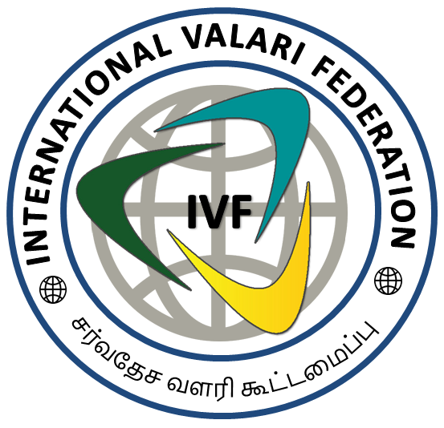
All prospective members of International Valari Federation (IVF) is required to complete this registration form. Indicate any changes; Membership runs from round the year. NEW MEMBERSHIP RENEWAL Changes for directory?
INTERNATIONAL VALARI FEDERATION
Category – National Members

SECTION 1: MEMBER CONTACT INFORMATION

TITLE | Mr Mrs Miss Ms Dr Prof
NAME OF PERSON
ORGANIZATION’S NAME
(Last working Job)
(Last working Job)

POSITION/  DESIGNATION |  | MAIN TELEPHONE
ADDRESS 1 |  | WORK TELEPHONE (if different)
ADDRESS 2 |  | HOME TELEPHONE
TOWN/CITY |  | MOBILE/WHATSAPP
ZIP CODE |  | PRIMARY EMAIL
COUNTRY: |  | SECONDARY EMAIL
*Star the e-mail and phone number you would like listed in the directory
SECTION 2: MEMBERSHIP TYPE AND PAYMENT DETAILS

Paste your recent colour photograph

MEMBER TYPE | DESCRIPTION | MEMBERSHIP DUES (Annual) | Please Check
NATIONAL | National Members -IVF is eligible Membership | No Fees

SECTION 3: MEMBER INFORMATION

OCCUPATION /INFORMATION/JOB TITLE:
Member IVF: Yes No Would you like to receive IVF/It’s Sister Organs membership information? : Yes No
Please indicate if you would be willing to serve on a National Membership etc.:
Yes Not at this time

Permission to use photographic images:
Photographs of IVF members may be used in various IVF communications incl. the newsletter and website. Group photographs taken at IVF events may be used without identifying individual members. For individual photographs, please indicate your permission for use:
_____ IVF/It’s Sister Organs have my permission to use and identify photographs of me.
_____ IVF/It’s Sister Organs does not have permission to use and identify photographs of me.
_____ IVF/It’s Sister Organs must contact me before using any identified photographs of me in IVF communications.

All disputes relating to membership, accreditation, services/privileges, issue of Identity Cards, Certificates and etc are governed by Civil Laws and Civil Courts only subject to Coimbatore, Tamilnadu, India Jurisdiction.

Declaration: I/We hereby declare that the details furnished above are true and correct to the best of my/our knowledge and belief and I/We undertake to inform you of any changes therein, immediately. In case any of the above information is found to be false or untrue or misleading or misrepresenting, I/We aware that I/We may be held liable for it. I/We hereby authorize sharing of the information furnished on this form with the International Valari Federation (IVF)

Date:______________________ Signature:________________________

